Lab tasks by 21SW159

**01. Write java code to take a value at runtime and searches it into array if the value is present then print its position else print value not present.**

import java.util.Scanner;

public class Main {

public static void main(String[] args) {

String dept;

char c;

Scanner sc = new Scanner(System.in);

System.out.println("enter a value");

dept = sc.nextLine();

System.out.println("enter value to search");

c = sc.nextLine().charAt(0);

for (int i = 0; i < dept.length(); i++) {

if (dept.toCharArray()[i] == c) {

System.out.println("value is present at index " + i);

System.exit(0);

}

}

System.out.println("value not found");

}

}

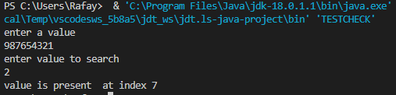

**02. Write a program to demonstrate concept of java runtime argument input your name and rollno. And print it on console.**

import java.util.Scanner;

public class Student {

public static void main(String[] args) {

String name;

String roll;

Scanner sc=new Scanner(System.in);

System.out.println("Enter Your name ");

name = sc.nextLine();

System.out.println("Enter your roll number");

roll = sc.next();

System.out.println("your name is " + name);

System.out.println("your roll number is "+ roll);

}

}

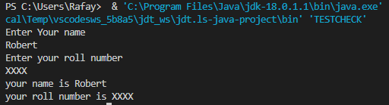

**03. Develop a java program that takes 5 float numbers at run time argument and print their sum.**

import java.util.Scanner;

public class Task {

public static void main(String[] args)

{

int i,n=0,s=0;

double avg;

{

System.out.println("Input the 5 numbers : ");

}

for (i=0;i<5;i++)

{

Scanner in = new Scanner(System.in);

n = in.nextInt();

s +=n;

}

avg=s/5;

System.out.println("The sum of 5 no is : " +s+"\nThe Average is : " +avg);

}

}

